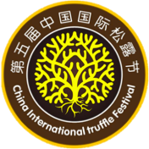
The Fifth Chinese (Nujiang, Yunnan) International Truffle Festival Congress, Nov. 6-9, 2017
Invitation Letter
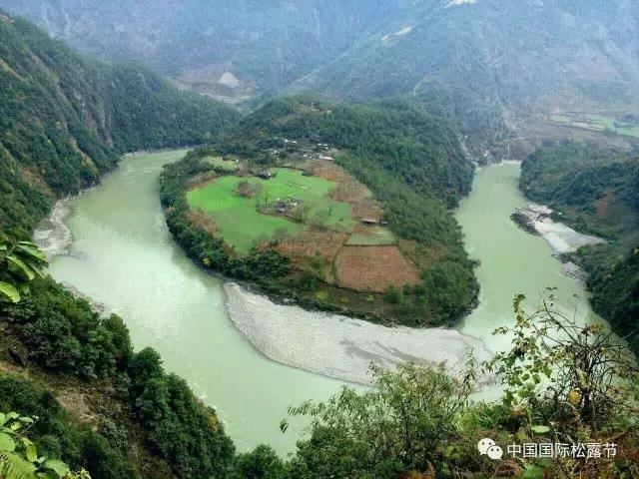
Truffles, commercially known as “Song-lu” in China, are one of three top ingredients of French cuisine that have been honored as “Black diamond of the kitchen” and “God’s food”. The two main areas of Black truffle production in the world are Europe (e.g. France, Italy, Spain) and along the Jinsha, Lancang, Salween rivers of China. Since entering international markets in the early 1990s, Chinese truffles have become a topic of global interest given their high levels of natural productivity. This has spurred developments pertaining to research on their diversity, production and conservation. The status of Chinese truffles continues to improve.
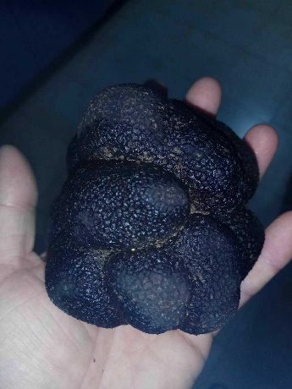
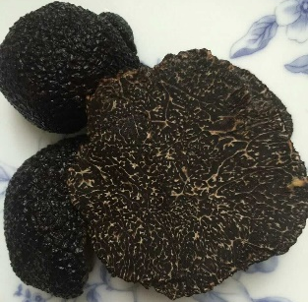
Nujiang Lisu Autonomous Prefecture, Yunnan, China is at the heart region of the three parallel rivers and is an important region of truffle diversity. This region is a ‘biodiversity hotspot’ characterized by a rich biota of plants, animals and fungi, and especially abundant wild mushroom resources. The Gongshan black truffle is an economically valuable species that is exported and has become the subject of much research and international interest. To protect and sustain truffle resource in China and to promote research and development of wild mushroom resources, we will hold “The Fifth Chinese (Nujiang) International Truffle Festival Congress”. The congress aims to improve the visibi- lity of Chinese truffles and to strengthen communication between Chinese and international truffle researchers and those involved in the truffle industry. Mean- while, it also aims to promote the cultivation of Chinese truffles and con- servation of natural resources, with the long-term goal of developing sustainable economic wealth in this mountainous region.
We welcome you to the “The Fifth Chinese (Nujiang) International Truffle Festival Congress” in Gongshan County, Nujiang Prefecture, Yunnan to be held November 6-9, 2017. Details of the Congress are provided below.
I. Organization Structure
(1) Host Units
People’s Government of Nujiang Lisu Autonomous Prefecture, Yunnan
Kunming Institute of Botany, Chinese Academy of Sciences
Yunnan Association for Science and Technology
Yunnan Association for Protection of Wild Mushrooms
(2) Organizer
People’s Government of Gongshan County
Nujiang Prefecture Forestry Bureau
www.emushroom.net
(3) Support Units
Forestry Department of Yunnan Province, Agricultural Department of Yunnan Province, Commerce Department of Yunnan Province, Science and Technology Department of Yunnan Province, Supply and Marketing Cooperative of Yunnan Province, Kunming Police Dog Base of the Ministry of Public Security, Institute of Mycology, Jilin Agricultural University, Yunnan Agricultural University, Yunnan Academy of Agricultural Sciences, Kunming Institute of Edible Fungi & Yunnan Association for Edible Fungi.
- Sponsors
Sichuan Golden Truffle Company
Yunnan Truffle Technology Company
Kunming Sennong Technology Company
Guangdong Golden Truffle Biology and Technology Company
- Academic Committee
Chairman: Academician Li Yu (China)
Executive Chairman: Liu Peigui (China), Pierre Sourzat (France)
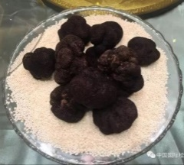
Members: Ian R. Hall (New Zealand)，Alexis Guerin-Laguette (New Zealand), Anne Mitchell (Australia), Asunción Morte (Spain), Carlos Colinas (Spain), Gregory Bonito (United States), Hu Hungtao (Taiwan, China), Jesus Pedrez (Mexico), Li Rongchun (China), Pierre Sourzat (France), Shanon Berch (Canada), Yang Zhuliang (China), Wang Xianghua (China), Zhang Tao (China), Zhao Yongchang (China), Chen Juan (China), Qiao Peng (China)
(6) Organizing Committee
Adviser: Prof. Liu Peigui
Director: Wang Shiping
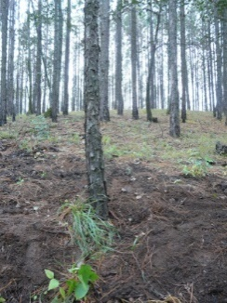
Executive members: Li Haishu, Yang Zhiquan, He Guoxiao, Zhang Shengming; Chu Guilin, Pan Wenhai, Li Honggao, Wang Xianghua, Chen Juan (China) and Tan Xinpei
(7) Interpreter
Wang Xianghua，Chen Juan，Zhang Rui，Wan Shanping，Wang Ran
II. Meeting Subject: Chinese (Nujiang) Truffle, EMM, Development, Opportunity & Challenge
III. Main Content and Purpose
Three subjects of the Academic Forum
1) Biodiversity of truffles and wild mushrooms and Conservation Biology
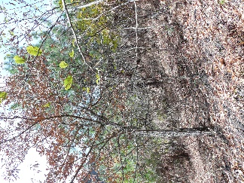
2) Truffle resources, Mycorrhizal technology, Application and scientific management and Practice of ecological civilization construction
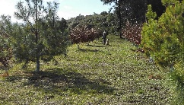
3) Discussion on the proposal of “Rules of Protection and Development of Wild Mushroom”, “Action Plan of Protecting Gongshan, Nujiang, China Truffles”, establishing and publishing “Collection Festival of Chinese Truffles (short for “Songlu Festival”) and declaring “Geographical Indication and Meaning of Gongshan Black Truffle”
IV. Trade Forum of Industry of Truffle and Wild Edible Mushroom
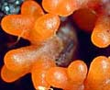
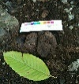
There are 30-50 stands in the meeting intended to invite international enterprises that work in the truffle and wild mushroom trade. This meeting will provide P2P face-to-face communication and conversation to promote harmonious development between ecology, society and green economy.
V. Three domains in Cultural Forum
(1) The meeting sets up popularization of mushroom science, precise collection demonstration and field training of truffle hunting (with pigs and dogs) and science exhibition of biological characteristics of truffle and other wild edible mushrooms. The meeting also will spread wild mushrooms’ characters and the function in the restoration of eco-environment and maintenance system.
(2) Demonstrate wonderful national art of different places by setting up drawing, stamp, artwork and photography show of truffles and other wild mushrooms.
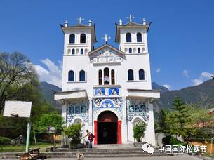
(3) Gourmet festival, to hold food tasting of truffles and other wild mushrooms to promote Chinese and Western combination, learn from each other and spread national cooking skills.
VI. Post-meeting field trip
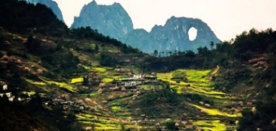
The post meeting field trip (3-4 days) includes the forest canopy ecology of the first bay of Nujiang gorge, Dulong River and Stone moon, and also includes outdoor collection of truffle and other wild macrofungi.
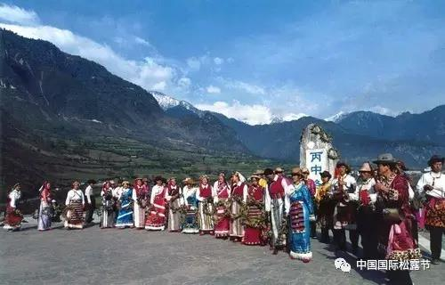
VII. Meeting time
November 6−9, 2017, Post-meeting field trip: November 10−13, 2017
VIII. Meeting place
Bingzhongluo Town, Gongshan County, Nujiang Lisu Autonomous Prefecture, Yunnan
IX. Registration fee
US$ 300 per attendee, US$ 150 per student. This fee includes: travel expenses during meeting, dinner, materials, and national characteristic souvenirs.
X. Post-meeting investigation fee: US$ 300 per person which includes admission fees, transportation and accommodation
XI. Commercial exhibition fee: stands (3m × 3m), US$ 350/stand.
XII. Sponsorship fee
The unit which sponsors US$1500 to the meeting could put own logo and brand in meeting information, annunciation, publication and other medium. The meeting will provide a medal to sponsors.
XII. Transportation
Plane: Kunming Changshui International Airport—Baoshan Airport, transfer bus to Gongshan
Train: Kunming Railway Station—Dali Railway Station, transfer bus to Gongshan
Bus: Kunming bus station—Liuku, transfer bus to Gongshan
XIII. Secretariat and contacts
Wang Xianghua, Kunming Institute of Botany, Chinese Academy of Sciences, Tel: 0086-13888420309, email: xhwang@mail.kib.ac.cn;
For more information, please visit websites below:
http://www.nujiang.cn/; http://www.kib.ac.cn/ ;
http://www.emushroom.net/
